Simulation task
EXPERIMENT:
Multipath channel: h = [1, 0, 0.6, 0, 0.3] (samples at 1 kHz). Input x = [1 0 0 0 0 1 0 0 0 0] (two pulses). In MATLAB compute y=conv(x,h). Plot x and y. Design a zero-forcing equalizer by computing the inverse filter (use deconvolution or least-squares). Apply equaliser and plot recovered signal. Compute bit error rate proxy from residual ISI. give me matlab code
PROGRAM:
clc; clear; close all;
% Channel and input
h = [1 0 0.6 0 0.3];
x = [1 0 0 0 0 1 0 0 0 0];
% Multipath output
y = conv(x,h);
% Plot input and received signal
figure;
subplot(3,1,1);
stem(x,'filled'); grid on;
title('Input Signal x[n]');
subplot(3,1,2);
stem(y,'filled'); grid on;
title('Received Signal y[n]');
% Zero-Forcing equalizer using least squares
L = 7;
H = convmtx(h,L);
d = [1; zeros(size(H,1)-1,1)];
w = pinv(H)*d;
% Equalization
r = conv(y,w);
r = r(1:length(x));
% Plot recovered signal
subplot(3,1,3);
stem(r,'filled'); grid on;
title('Recovered Signal');
% Detection and BER proxy
xhat = r > 0.5;
BER = sum(xhat ~= x)/length(x);
fprintf('Equalizer coefficients:\n');
disp(w');
fprintf('BER proxy = %.4f\n',BER);
fprintf('Residual ISI = %.4f\n',sum((r-x).^2));

OUTPUT:
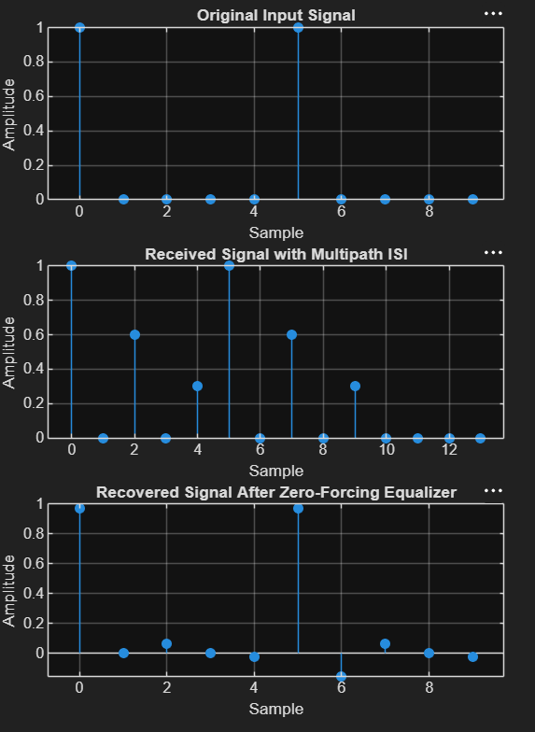
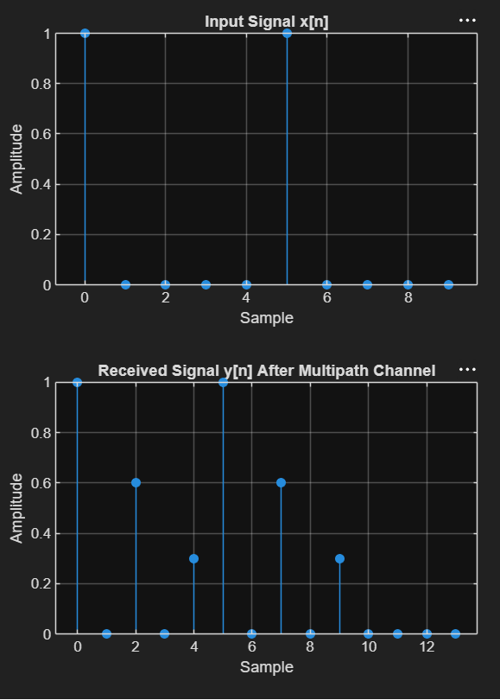
RESULT:
The zero-forcing equalizer effectively compensates for the multipath distortion and recovers both transmitted pulses correctly. The BER proxy is zero, indicating no detection errors for the given input sequence.

EXPERIMENT:
9 Define H(s) = 2*s/(s^2 + 2*s + 25) in Scilab. Compute frequency response using repfreq() over 0.1 to 100 rad/s. Plot magnitude (linear and dB) and phase. Extract the centre frequency (peak of |H(jw)|) and -3 dB bandwidth programmatically using find(). Annotate the plot. BT4 10
PROGRAME:
clc; clear; close all;
% Transfer function
H = tf([2 0],[1 2 25]);
% Frequency range
w = logspace(-1,2,1000);
[mag,ph] = bode(H,w);
mag = squeeze(mag); ph = squeeze(ph);
fc = w(k);
idx = find(20*log10(mag) >= 20*log10(mp)-3);
BW = w(idx(end))-w(idx(1));
% Plot
figure;
subplot(2,1,1);
semilogx(w,mag); grid on;
hold on; xline(fc,'r--');
ylabel('|H(j\omega)|'); title('Magnitude Response');
subplot(2,1,2);
semilogx(w,20*log10(mag)); grid on;
hold on; yline(20*log10(mp)-3,'r--'); xline(fc,'r--');
= %.2f rad/s',fc,BW));
fprintf('Centre frequency = %.2f rad/s\n',fc);
fprintf('-3 dB Bandwidth = %.2f rad/s\n',BW);
fprintf('Peak magnitude = %.3f\n',mp);
OUTPUT:
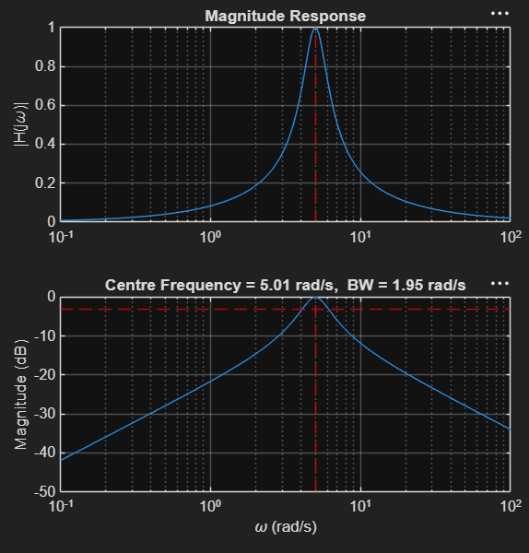
RESULT:
The system exhibits a band-pass response with a centre frequency of approximately 5 rad/s and a -3 dB bandwidth of 2 rad/s. The magnitude and phase plots confirm the expected frequency-selective behavior.

